

**UNIVERSITY OF PETROLEUM & ENERGY STUDIES**

**Dehradun**

**APPLICATION CONTAINERISATION**

**Name: Shivani Chauhan**

**Course: B. TECH CSE DevOps (2018-22)**

**Roll no.: R171218096**

**Sapid: 500068969**

**Experiment No. 12**

**Build Docker Image using .dockerignore file**

**In this experiment, we are going to use a concept similar to .gitignore which is called .dockerignore file. It allows us to ignore some sensitive, important or large files from being included in images.**

**To prevent sensitive files or directories from being included by mistake in images, you can add a file named *.dockerignore*.**

**Follow these steps below:**

**1. Create a dockerfile which actually copies the working directory into the Docker Image. As a result, this would include potentially sensitive information such as a passwords file which we'd want to manage outside the image.**

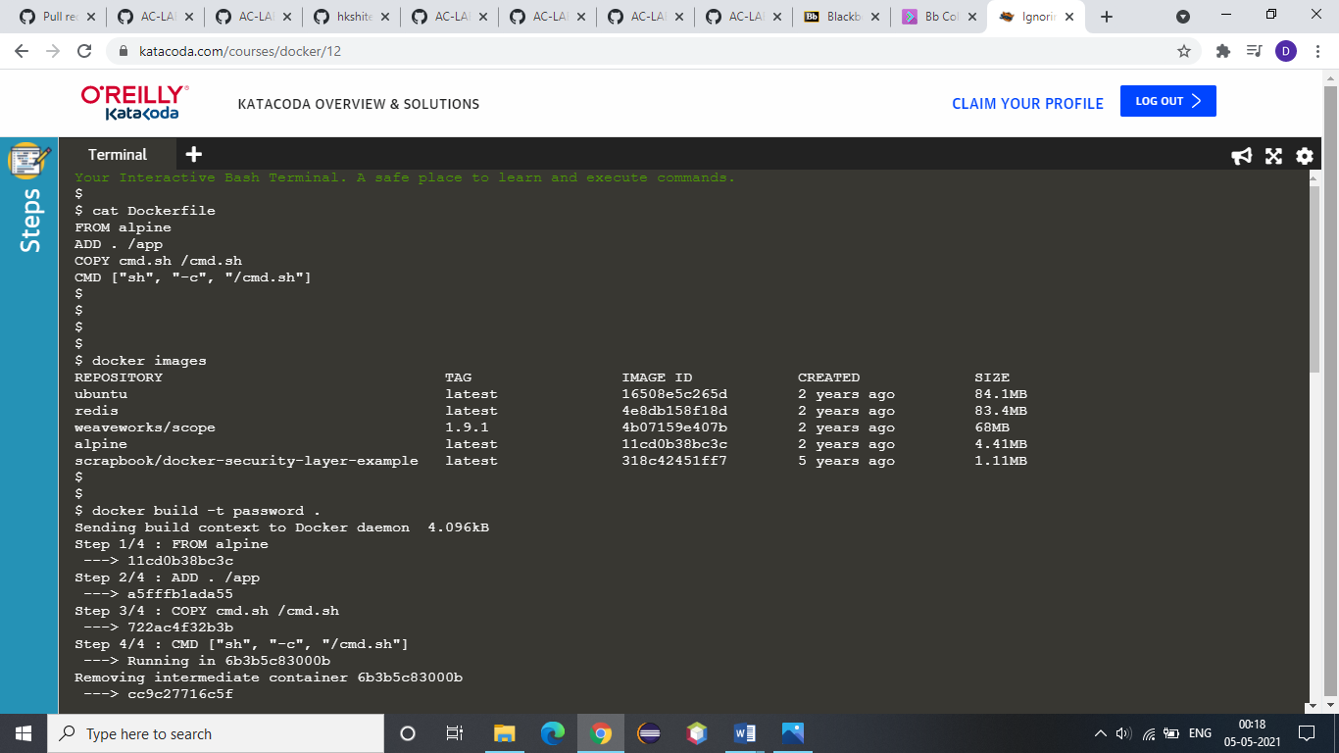

**2. Check for the existing images first:**



**3. Build the image using the following command:**

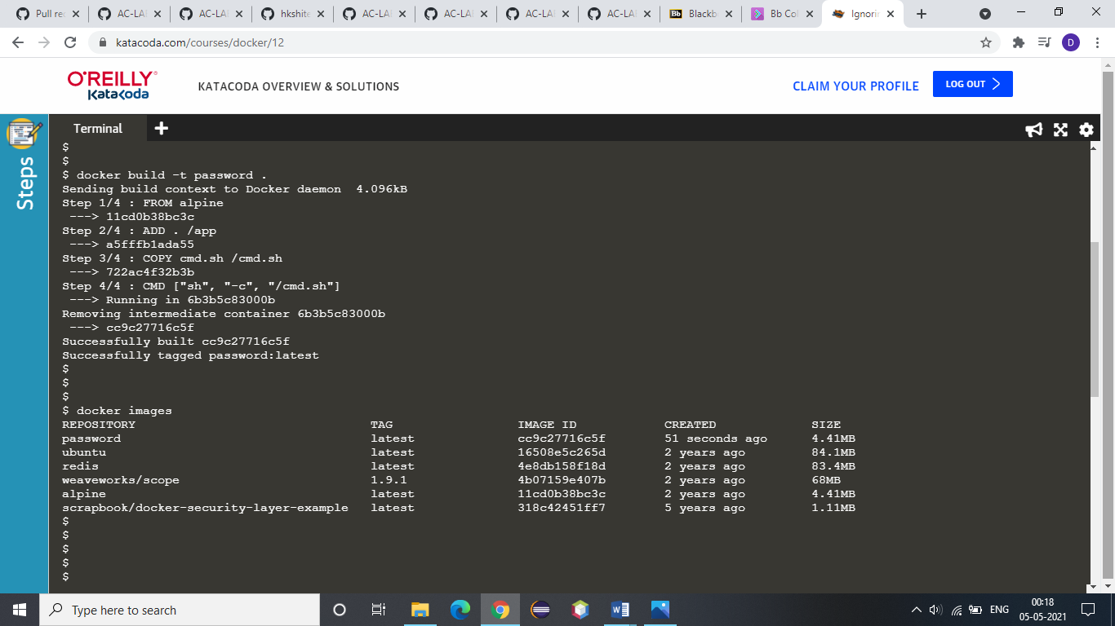

**4. Now, check that the newly created image is build or not!**



**5. Look at the output using docker run password ls /app**

**This will include the passwords file.**

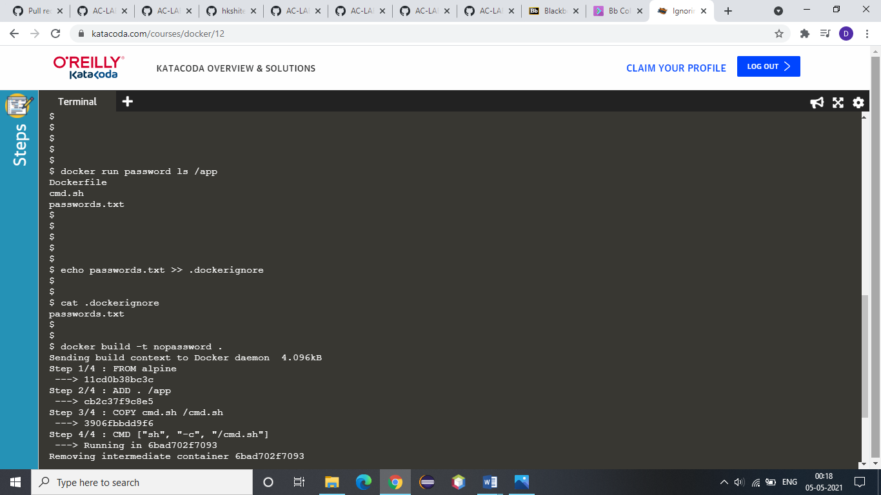

**6. Now, we are going to use a command which would include passwords.txt in our *.dockerignore* file and ensure that it didn't accidentally end up in a container. The *.dockerignore* file would be stored in source control and share with the team to ensure that everyone is consistent.**



**7. Now, build the image, because of the Docker Ignore file it shouldn't include the passwords file.**

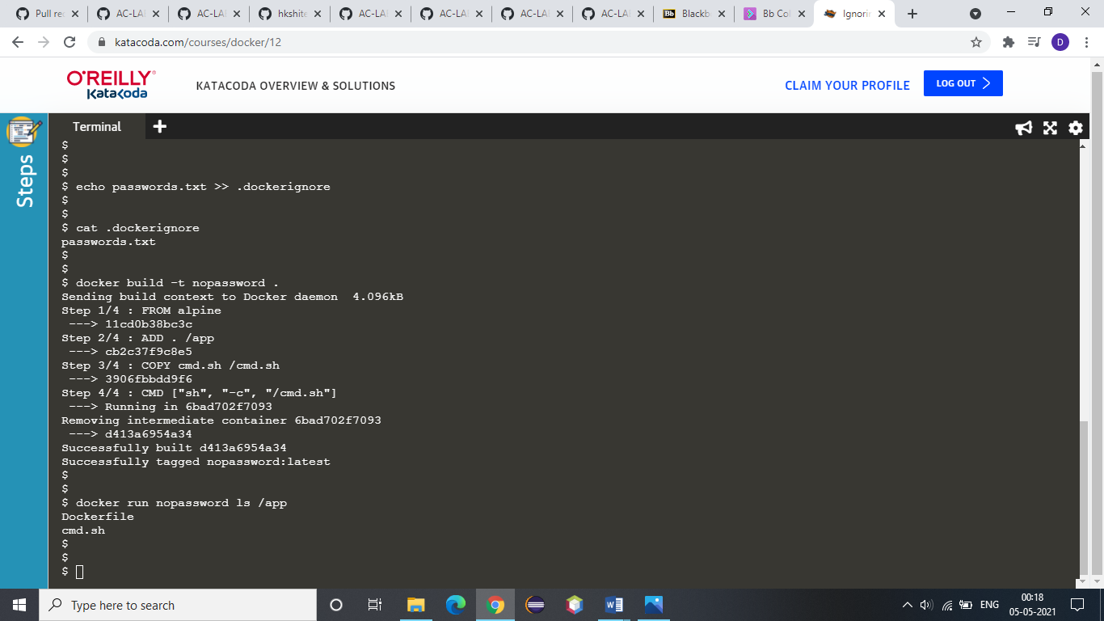

**8. Look at the output using:**



**9. Now, we are creating a 100M file which is never used the dockerfile. Now, create a build which will include this large file and notice its impact on build performance:**

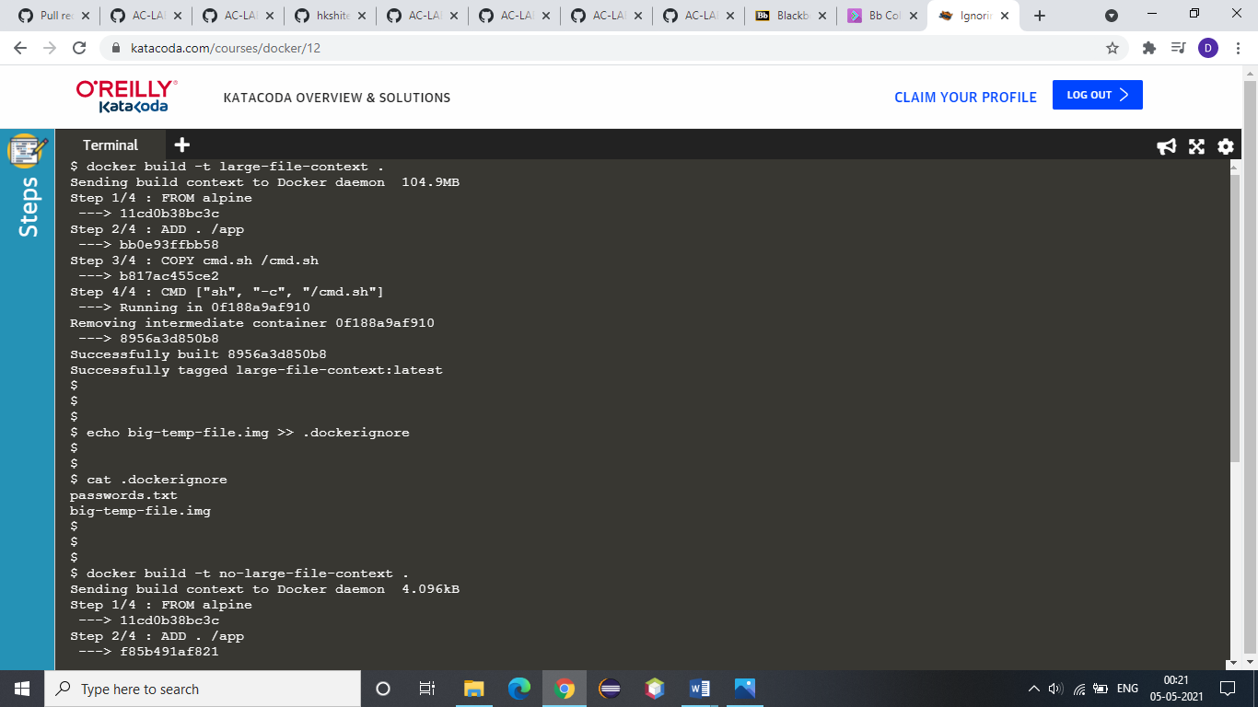

**10. Now, to optimize the build, to speed up our build, simply include the filename of the large file in the ignore file.**



**11. When we rebuild the image, it will be much faster as it doesn't have to copy the 100M file.**

